CorrectBranchStaff-O365Set-up.docx, 1/16/2016
Correct set-up for Branch Staff that has shared mailboxes. Both K1 AND Exchange Online Plan 1 should be selected. (K1 is minus “Exchange Online Kiosk”). All others (may include agents) should just be PlanK1 so that they can have Yammer and SharePoint.
O365 Admin Center Portal
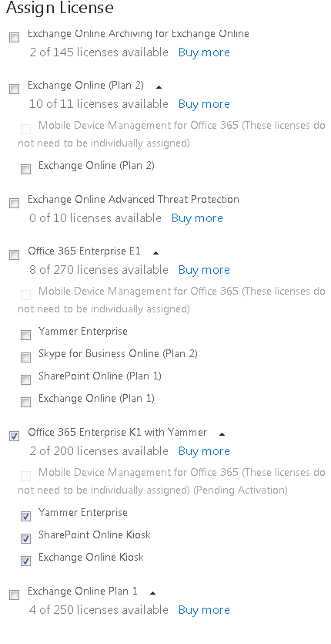

CT/JAMCO ONLY

CT/JAMCO ONLY(?)

Beta Testing Dec (2015)

Full Package for select few staff/corporate users (Jodi or Lisa to approve)

POP3 Only, for agents & branch staff w/o shared mailboxes

Remove Exchange Online Kiosk if shared mailbox access needed. Select Exchange Online Plan 1 instead.

Select only if shared mailbox access is needed. If selected remove "Exchange Online Kiosk". K1 still needed for Yammer and SharePoint access.

